Factorplot or Catplot summary

This dataset for 90 patients pluse rage .it’s said what kind of exercise should be done with this dataset.

It’s run is catplot from seaborn.i’m take to xlabel for time and ylable for pulse rate.

tttttttttT

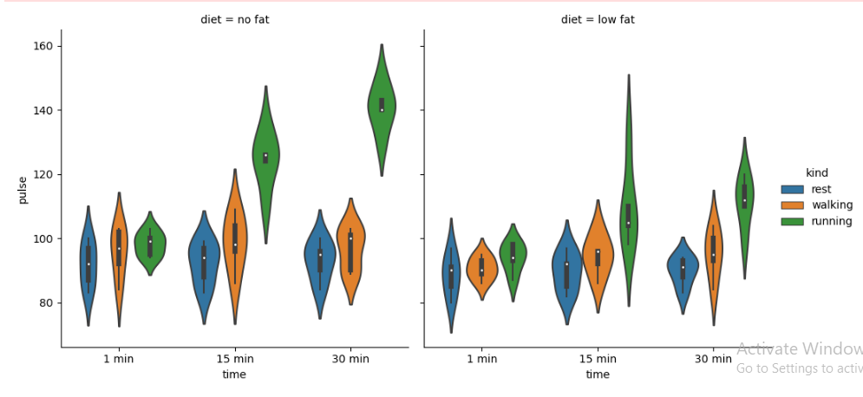

The plot for violin and include Boxplot. 90 patients were studied the first one is diet for no fat, and it’s take to different time (1min,15min,30min) and kind is rest(blue) walking(orang) and running(Green).

Diet for no fat

When some patients are cheek pulse at 1min for 70 to 110 some of them 80 to 100 so doctor said you are take rest and another is starting same 70 to 115 but high rang is 90 to 105 , so doctor said you are walking daily, and another is starting 90 to 105 but he said running daily.

When the same patients are check for pulse at 15min 70 to 105 some of them 85 to 95 so he said you are take rest, and another is starting same but end is high70 to 122 but most of patients pulse 95 to 105 so he said you are walking daily and another is starting 100 to 150 but most of patients pulse 120 to 130 so he said you are running daily.

When the same patients are check for pulse at 30min 75 to 105 some of them 85 to 95 so he said you are take rest, and another is starting 80 to 100 but most of patients pulse 90 to 105 so he said you are walking daily and another is starting 120 to 160 but most of patients pulse 140 to 150 so he said you are running daily.

Diet for low fat

When some patients are cheek pulse at 1min for 65 to 110 some of them 80 to 95 so he said you are take rest and another is starting same 70 to 115 but high rang is 85 to 95 , so he said you are walking daily, and another is starting 80 to 105 but he said running daily.

When the same patients are check for pulse at 15min 70 to 110 some of them 80 to 95 so he said you are take rest, and another is starting 80 to 110 but most of patients pulse 90 to 100 so he said you are walking daily and another is starting 80 to 140 but most of patients pulse 90 to 110 so he said you are running daily.

When the same patients are check for pulse at 30min 75 to 95 some of them 85 to 90 so he said you are take rest, and another is starting70 to 110 but most of patients pulse 90 to 100 so he said you are walking daily and another is starting 85 to 130 but most of patients pulse 100 to 115 so he said you are running daily.